
Lab assignment 4
Submitted by: Tayyaba Hussein
Registration: SP24-BSE-059
Course: Information security (lab)
Instructor: Ms. Ambreen Gul
Program: Software engineering

Question 1: Simple RSA Implementation (Without Libraries) Objective: Understand the math behind RSA Tasks:
• Manually implement key generation using small primes
• Write functions for: o encrypting a message (using public key) o decrypting a message (using private key)
• Test it on your name or a short string

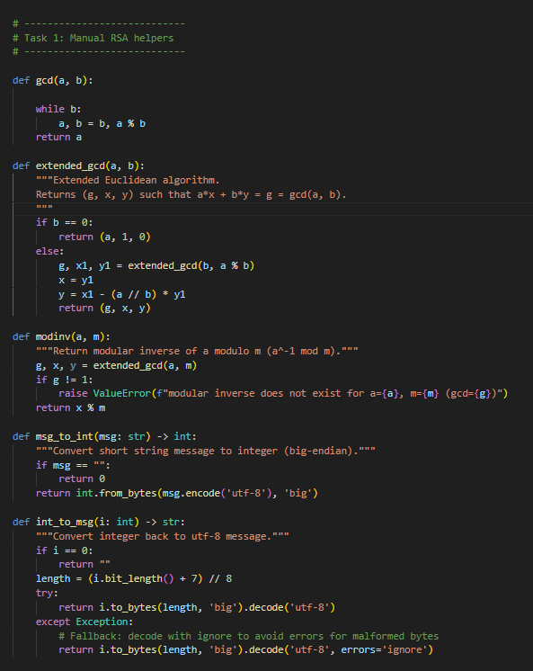

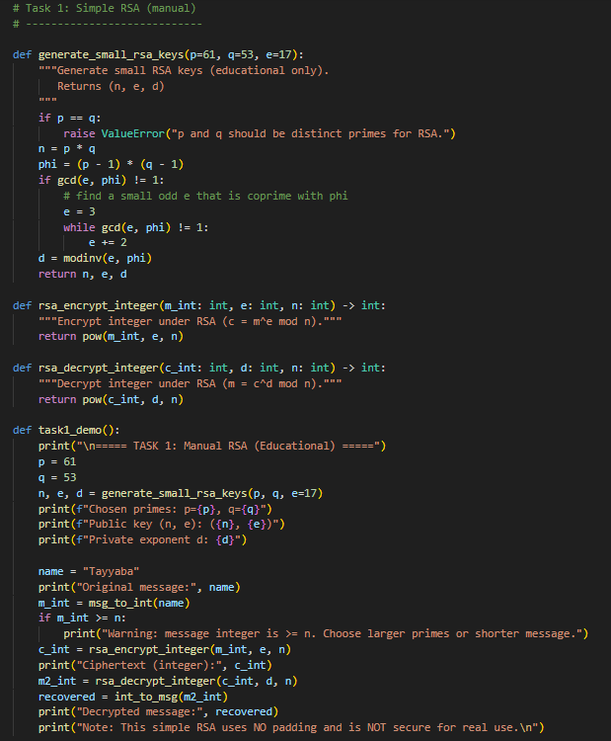

OUTPUT:
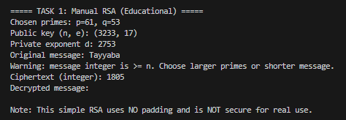

Question 2: RSA with PyCryptodome
Objective: Use real-world cryptographic libraries Tasks:
• Generate a 2048-bit key pair
• Encrypt and decrypt a user message
• Display results in hex

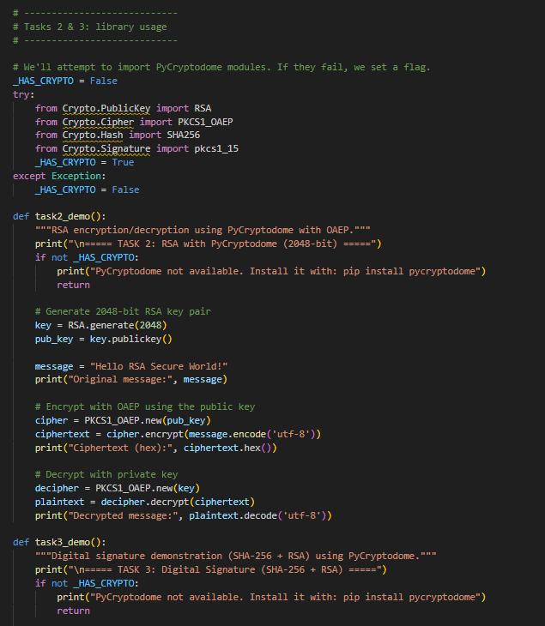

Output:

Question 3: Create a Digital Signature Objective: Understand digital signatures Tasks:
• Generate RSA key pair
• Create a hash of a message (e.g., using SHA256)
• Sign the hash using private key
• Verify it using the public key
• Modify the message slightly and show that verification fails
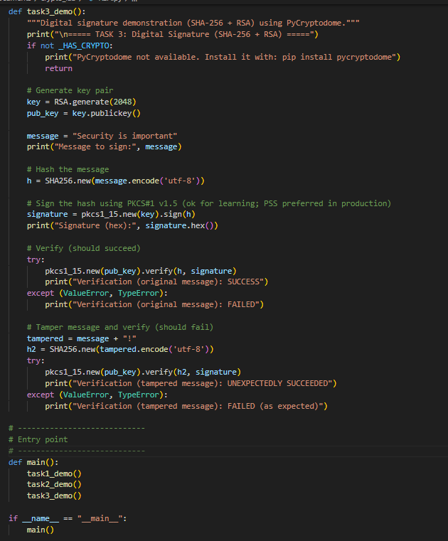

OUTPUT:

